Austin Smothers

CISP 310

Assignment 4
; NumMax.asm, a program which finds the maximum
; between two numbers
; Austin Smothers
; CISP 310
; October 23, 2017

.586
.MODEL FLAT

INCLUDE io.h

.STACK 4096

.DATA
num1 DWORD ?
num2 DWORD ?
numLrg BYTE 11 DUP (?), 0
promptNum BYTE "Enter the first Number", 0
promptNum2 BYTE "Enter the second Number", 0
string DWORD 40 DUP (?)
resultLbl1 BYTE "Larger number", 0

.CODE
_MainProc PROC
input promptNum, string, 40 ; read ASCII characters
atod string ; convert to integer
mov num1, eax ; eax in num1

input promptNum2, string, 40 ; read ASCII characters
atod string ; convert to integer
mov num2, eax ; eax in num2

mov eax, num2 ; num2 in eax
cmp eax, num1 ; compare two numbers

jg numGreater ; jumps if num2 is greater

mov eax, num1 ; we didn't jump, num1 is greater
; store it in eax
dtoa numLrg, eax ; convert eax to DWORD, store in numLrg

jmp exit ; skip the numGreater case

numGreater: dtoa numLrg, eax ; convert eax to DWORD, store in numLrg

exit: output resultLbl1, numLrg ; output numLrg

mov eax, 0 ; reset eax

ret
_MainProc ENDP
END ; end of source code
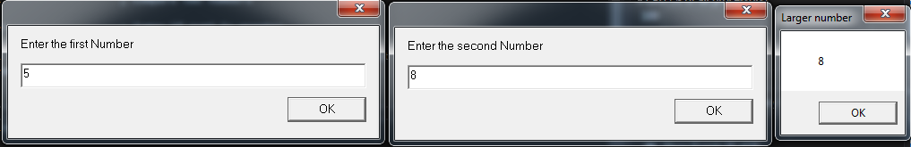
; NumMax3.asm, a program which finds the maximum
; between three numbers
; Austin Smothers
; CISP 310
; October 23, 2017

.586
.MODEL FLAT

INCLUDE io.h

.STACK 4096

.DATA
num1 DWORD ?
num2 DWORD ?
num3 DWORD ?
numLrg1 DWORD ?
numLrgFin BYTE 11 DUP (?), 0
promptNum BYTE "Enter the first Number", 0
promptNum2 BYTE "Enter the second Number", 0
promptNum3 BYTE "Enter the third Number", 0
string DWORD 40 DUP (?)
resultLbl1 BYTE "Largest number", 0

; main program on next page
.CODE
_MainProc PROC
input promptNum, string, 40 ; read ASCII characters
atod string ; convert to integer
mov num1, eax ; eax in num1

input promptNum2, string, 40 ; read ASCII characters
atod string ; convert to integer
mov num2, eax ; eax in num2

input promptNum3, string, 40 ; read ASCII characters
atod string ; convert to integer
mov num3, eax ; eax in num3

mov eax, num2 ; num2 in eax
cmp eax, num1 ; compare num2 and num1

jg numGreater ; jumps if num2 is greater

mov eax, num1 ; we didn't jump, num1 is greater
; store it in eax

numGreater: mov numLrg1, eax ; store eax in numLrg1
; (if we jumped, num2 is in eax)

; at this point, the larger between num1 and num2 is stored in numLrg1 as an int

mov eax, num3 ; store num3 in eax
cmp eax, numLrg1 ; compares num3 and numLrg1

jg num2Greater ; jumps if num3 is greater

mov eax, numLrg1 ; we didnt jump, store numLrg1 in eax

num2Greater: dtoa numLrgFin, eax ; store eax in numLrgFin
; (if we jumped, num3 is in eax)

output resultLbl1, numLrgFin ; output numLrgFin

mov eax, 0 ; reset eax

ret
_MainProc ENDP
END ; end of source code

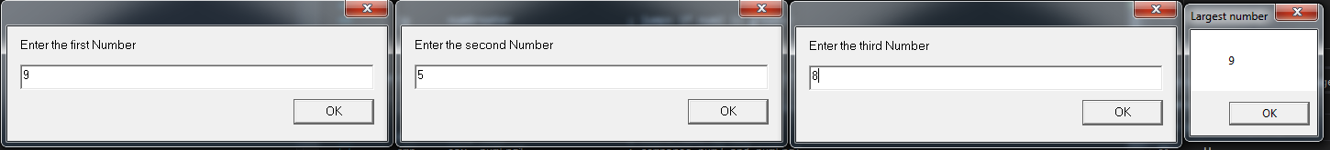
; NumOdd.asm, a program which finds if
; a number is odd or even
; Austin Smothers
; CISP 310
; October 23, 2017

.586
.MODEL FLAT

INCLUDE io.h

.STACK 4096

.DATA
promptNum BYTE "Enter a Number", 0
string DWORD 40 DUP (?)
resultLbl BYTE "The Number is", 0
resultOdd BYTE "Odd", 0
resultEven BYTE "Even", 0

.CODE
_MainProc PROC
input promptNum, string, 40 ; read ASCII characters
mov eax, string ; store input string in eax (divisor)
mov edx, 0 ; initialize edx (stores remainder)

mov ecx, 2 ; create the dividend
div ecx ; num1 / 2

cmp edx, 0 ; compare remainder (stored in edx)
; to 0 (stored in eax)
; any even number will have a remainder of 0, and odd a remainder of 1

jz evenNumber ; jump if the number is even
; (zero flag will be set)

output resultLbl, resultOdd ; didn't jump, result is odd, output
jmp exit ; jump past the even number output

evenNumber: output resultLbl, resultEven ; jumped, result is even, output

exit:

mov eax, 0 ; reset eax
mov ecx, 0 ; reset edx
mov edx, 0 ; reset ebx

ret
_MainProc ENDP
END ; end of source code
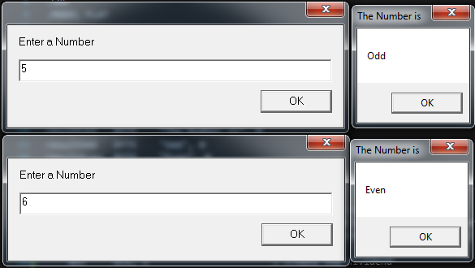
; PosNeg.asm, a program which finds if
; a number is positive, zero, or negative
; Austin Smothers
; CISP 310
; October 23, 2017

.586
.MODEL FLAT

INCLUDE io.h

.STACK 4096

.DATA
num1 DWORD 11 DUP (?), 0
promptNum BYTE "Enter a Number", 0
string DWORD 40 DUP (?)
resultLbl BYTE "The Number is", 0
resultNeg BYTE "Negative", 0
resultPos BYTE "Positive", 0
resultZero BYTE "Zero", 0

.CODE
_MainProc PROC
input promptNum, string, 40 ; read ASCII characters
atod string ; convert string to decimal
mov num1, eax ; put eax in num1

cmp num1, 0 ; compare eax to 0. (ZF set if 0, SF set if Neg)

jz zeroNumber ; jump if the number is zero
jg posNumber ; number isn't zero, jump if positive
jmp negNumber ; number isnt zero and isnt pos, must be neg

zeroNumber: output resultLbl, resultZero ; result is zero
jmp exit

posNumber: output resultLbl, resultPos ; result is positive
jmp exit

negNumber: output resultLbl, resultNeg ; result is negative
jmp exit

exit:

mov eax, 0 ; reset eax

ret
_MainProc ENDP
END ; end of source code
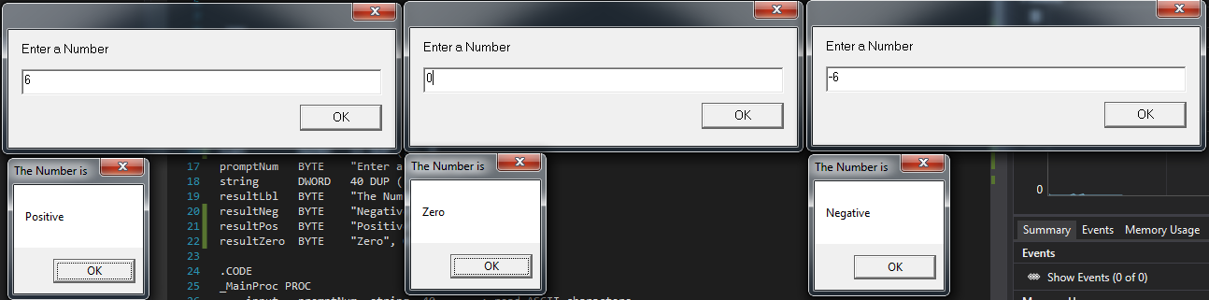
Sorry for the sideways pictures professor. I’ll make sure they don’t happen next time. Was rushing to get this one done a bit.

